1. Ways to define a Thread
2. By extending Thread Class
3. By implementing Runnable Interface
4. Method to prevent Thread execution
5. Yield ()
6. Join ()
7. Sleep ()
8. Inter Thread Communication
9. Wait
10. Notify
11. Notify All

**User and Daemon Thread**

1. **User threads** are created by the application (**user**) to perform some specific task. Whereas

**daemon threads** are mostly created by the JVM to perform some background tasks like garbage collection.

1. JVM will wait for **user threads** to finish their tasks. JVM will not exit until all **user threads**

finish their tasks.

**Multitasking:**

Executing several tasks simultaneously is the concept of Multitasking. There are 2 types of multitasking.

1. **Process Based**: Executing several tasks simultaneously where each task is separate independent program(process) is called process based multitasking.

**Ex**: 1. Typing a Java Program in editor.

2. Listening audio songs from system.

3. Downloading a file from internet.

All these tasks executed simultaneously independent of each other. This type of multitasking is applicable in OS level.

1. **Thread Based:** Executing several tasks simultaneously, where each task is separate independent part of same program. Each independent part is called a thread.

Thread based multitasking is best suitable at programmatic level.

**Advantage of Multitasking:** Weather it is process or thread based, the main objective of multitasking is to reduce the response time of system and to improve performance.

**Where we can use Multithreading concepts:**

To develop multimedia graphics

To develop animation

To develop Video Games

To develop Web servers and application servers etc.

To develop web server and application servers etc. Tomcat has by default 60 thread in the server.

When compared with old languages developing multi-threaded applications in java is very easy. Because Java provides inbuilt support for multi-threading with rich API by (Thread, Runnable, Thread Group)

Thread is a flow of execution. For every thread, a separate independent job is there.

**Defining a thread:**

We can define a thread in following 2 ways:

1. By extending Thread Class
2. By Implementing Runnable Interface.

**By Extending Thread Class:**

Create a class by extending the Thread class and override the run method. Main thread creates child thread object. Main thread starts child thread. Job of child thread is to execute the code written inside run () method.

Class MyThread extends Thread {

Public void run () {

----------------------------Job of thread------------

}

}

Every Java program contains only one normal thread i.e. Main Thread

To start the thread:

Class ThreadDemo {

Psvm (String[] args) {

**--In this point 1 thread--**

MyThread t = new MyThread ();🡪 **Thread Instantiation. Main thread creates a child thread.**

t.start();🡪**main thread starting of the child thread**

**--After t.start () In this point 2 thread---**

}

}

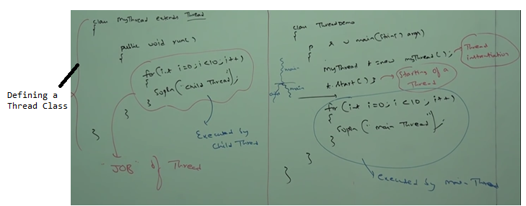

Possible outputs for above program:

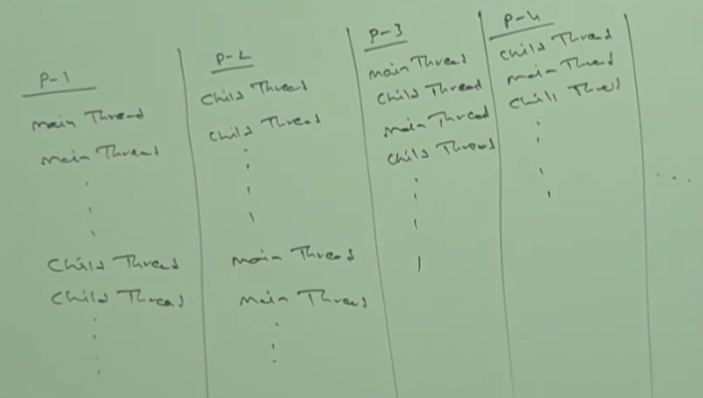

**Case-1:**

**Thread Scheduler**: It is the part of JVM. It is responsible to schedule threads i.e. if multiple threads are waiting to get the chance of execution then in which order threads will be executed is decided by Thread Scheduler.

We can’t expect exact algorithm followed by thread scheduler. It is varied from JVM to JVM. Hence, we can’t expect thread execution order and exact output. Whenever situation comes to multi-threading there is no guarantee for exact output but we can provide several possible outputs.

**Case2:**

Whenever we are calling t.start() then start method of **Thread** class will be executed. So, thread class start method is responsible to start our thread. Thread class start method internally calls the run method.

**Difference between t.start() and t.run()**

In case of t.start🡪 2 thread A new thread will be created and that thread is responsible for execution of run method our job.

In case of t.run🡪 only 1 thread. No thread will be created and run method will be executed just like normal method call by the main thread only. There won’t be any separate thread in this case.

In the above program if we replace t.start with t.run then the output is :

Child Thread 10 times followed by Main Thread 10 times. This total output produced by only main thread.

**Case3:** Without executing thread class start method there is no chance of starting a new thread java.

**Importance of Thread class start method:**

Thread class start method is responsible to register the thread with thread scheduler and all other mandatory activities. Hence, without executing thread class start method there is no chance of starting a new thread in java. Due to this, Thread class start method is considered as heart of multi-threading.

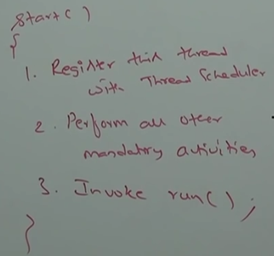

**Case4: Overloading of run method**

Overloading of run method is always possible. But thread class start method can invoke no argument run method. The other overloaded method we have to call explicitly like a normal method call.

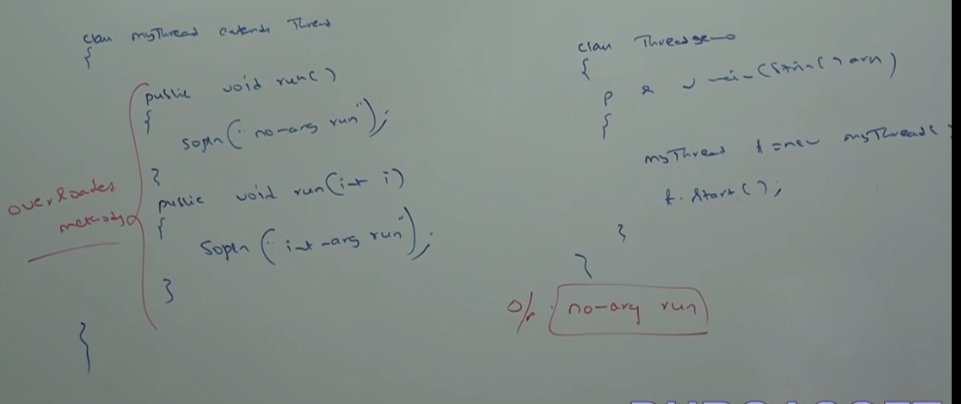

**Case 5:** If we are not overriding run method then thread class run method will be executed which has empty implementation. Hence, we won’t get any output.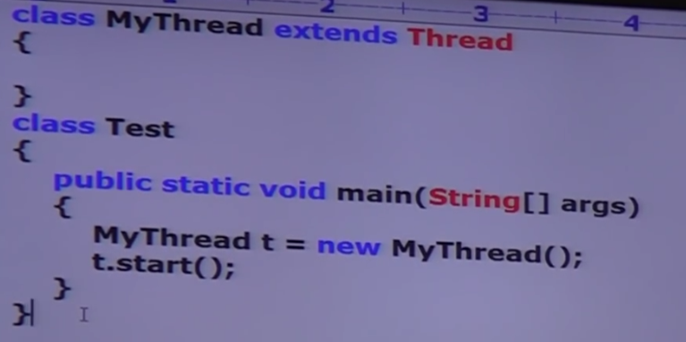

O/p: No output

It is highly recommended to override run method. Otherwise don’t go for multi-threading concept.

**Case 6: Overriding of start method**

Start method of child class will be executed just like normal method. No new thread will be created.

If we override start method then our start method will be executed just like a normal method call and new thread won’t be created.

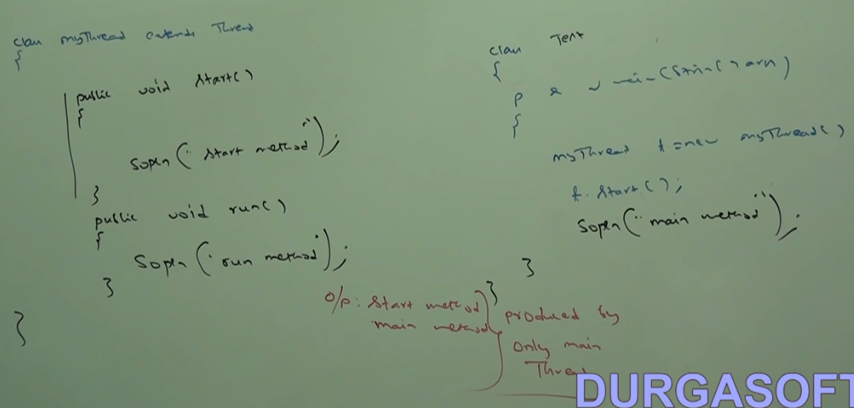

It is not recommended to override start method. Otherwise don’t go for multi-threading concepts.

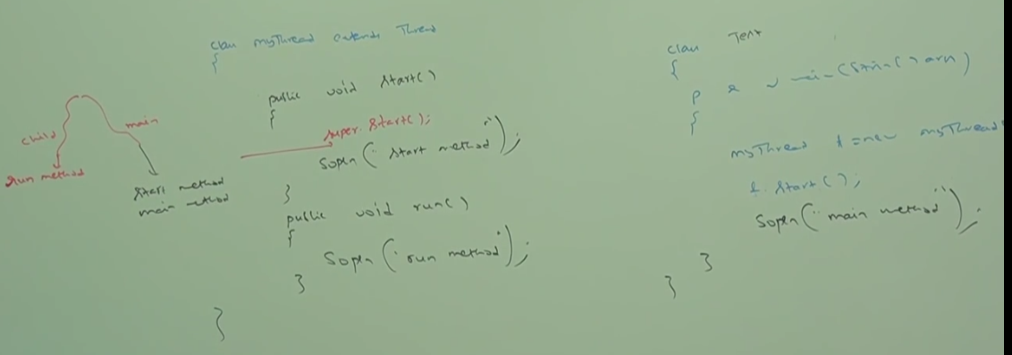

Possible output:

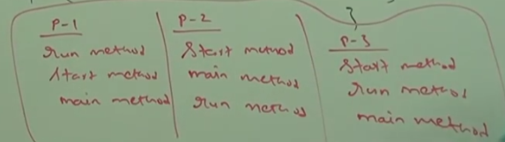

**Case 7: Thread Life Cycle**

Simple life cycle of Thread Life cycle

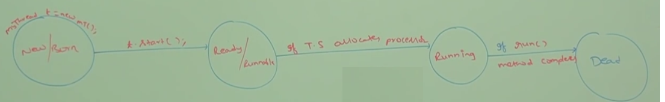

**Case 8:**

After starting a thread if we are trying to restart the same thread, then we will get run time exception saying IllegalThreadState exception**.**

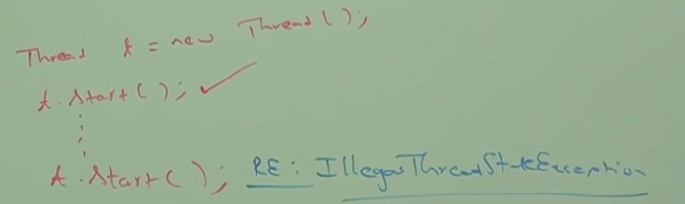

**Defining a thread by Implementing Runnable Interface:**

Thread by default implements Runnable interface. We can define a thread by implementing Runnable Interface.

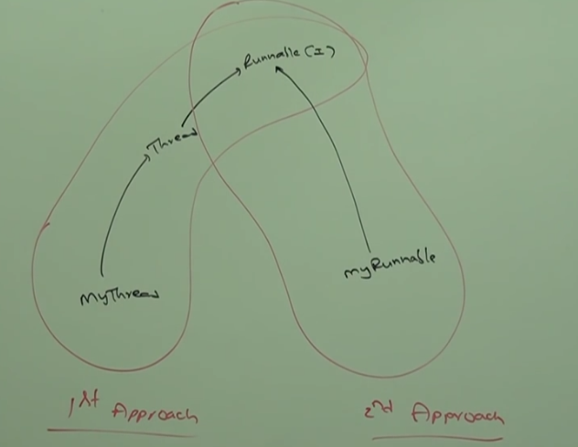

Runnable Interface present in java.lang package and contains only 1 method i.e.

Public void run ();

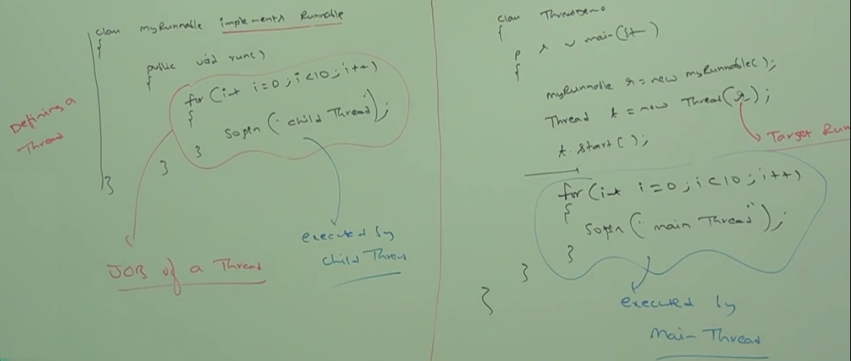

MyRunnable does not have start method. So, we need to create a thread class and runnable instance to start the thread.

MyRunnable r = new MyRunnable();

Thread t1 = new Thread ();

Thread t2 = new Thread (r);

**Case1:** t1.start (); 🡪New Thread will be created which is responsible for the execution of thread class run method which has empty implementation.Nothing will be printed as thread run method does not have anything.

**Case2:** t1.run() 🡪 No new thread will be created and run method of Thread class will be executed just like normal method call.

**Note*:** New thread will be created only when the start method is executed/called.

**Case3:** t2.start ()-> New Thread will be created which is responsible for the execution of MyRunnable class run method.Proper way of thread implementation.

**Case4:** t2.run (); ->t2 is created with MyRunnable class. So, MyRunnable run method will be executed just like a normal method call. No new thread will be created.

**Case5**: r.start (); 🡪we will get compile time error saying MyRunnable class does not have start capability. Runnable Interface does not have start method

Cannot find symbol: method start ()

Location class MyRunnable

**Case6**: r.run (); 🡪 No new thread will be created and MyRunnable run method will be executed just like normal method call.

**Which approach is best to define a thread.**

Among 2 ways of defining a thread, implements runnable approach is recommended.

In the 1st approach, our class always extends thread class, there is no chance of extending any other class. Hence, we are missing inheritance benefit.

But in the 2nd approach, while implementing runnable interface we can extend any other class. Hence, we won’t miss any inheritance benefit.

Because of above reason implementing Runnable interface to create a thread is recommended then extending thread class.

For every thread JVM creates a runnable stack.

**Thread class constructors:**

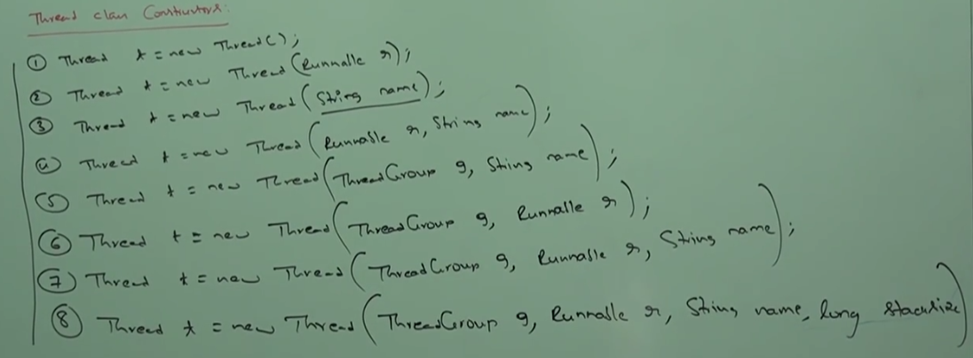

**3rd approach to create a thread:**

Instead of passing runnable instance to thread class constructor we can pass thread object itself which internally implements Runnable Interface.

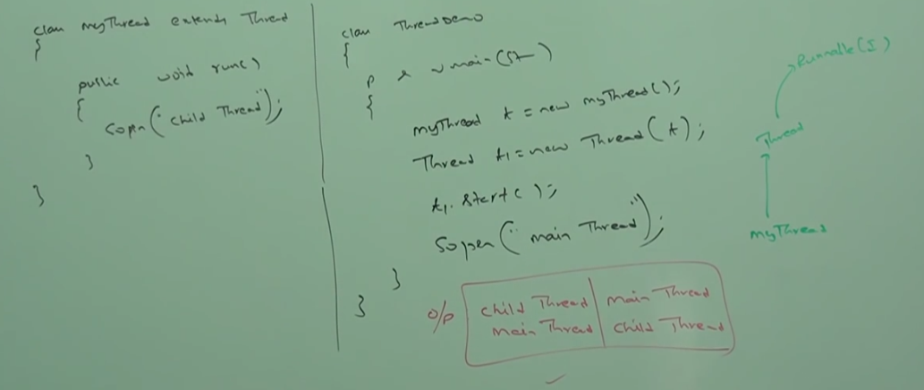

**Getting and Setting name of a thread:**

Every thread in java has some name. It may be default name generated by JVM or customized name provided by programmer.

We can get and set name of a thread by using getName () and setName () methods of thread class.

Thread.currentThread().getName ->Currently executing thread name.

**Main thread is responsible to execute main method.**

We can get current executing thread object by using **Thread.currentThread** method.

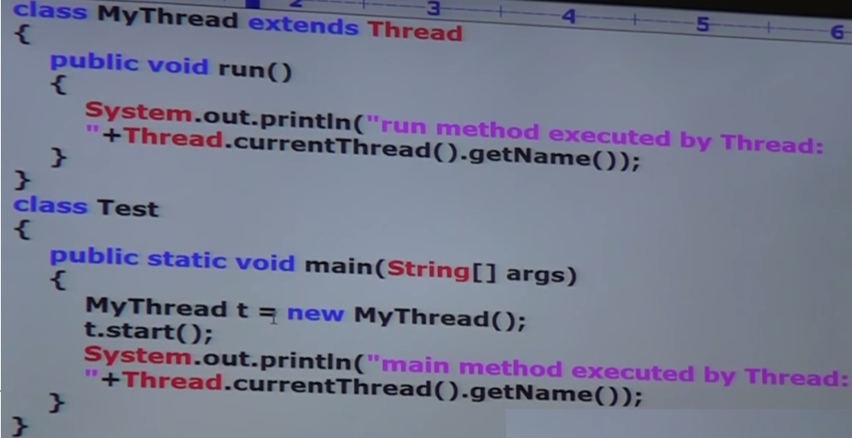

o/p: 

**Thread Priorities:**

Every thread in java has some priority. It may be default priority generated by JVM or customized priority provided by programmer.

Valid range of thread priorities is 1:10. Where 1 is min priority and 10 is max priority.

Thread scheduler will use priorities while allocating processor. Thread which is having highest priority will get the chance first.

If 2 threads are having same priority then we can’t expect exact execution order. It depends on thread scheduler.

1-Min Priority—Thread.MIN_PRIORITY 5-Thread.NORM_PRIORITY

10- Max Priority—Thread.MAX_PRIORITY

Public final int getPriority ()

Public final void setPriority (int p)—Allowed range 1 to 10. Else Illegal Argument exception.

**Default Priority:**

The default priority only for main thread is 5. For all remaining threads default priority will be inherited from parent to child i.e. whatever priority parent thread has the same priority will be there for the child thread.

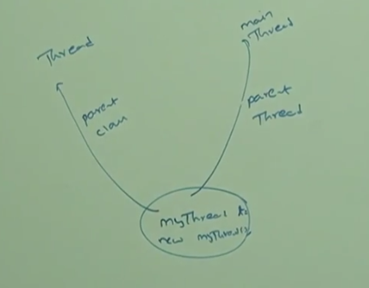

Parent thread is the main thread which calls the child thread.

**Some of the Operating system won’t provide support for thread priority.**

Methods to prevent thread execution:

We can prevent a thread execution by using the following methods:

* + - 1. Yield
      2. Join
      3. Sleep

**Yield method:** Yield method causes to pause the current executing thread to give the chance to waiting threads of same priority. If there is no waiting thread or all waiting threads have low priority then same thread can continue its execution.

If multiple threads are waiting with same priority then which waiting thread will get the chance we can’t expect. It depends on thread scheduler.

The thread which is yielded, when it will get the chance once again –It depends on Thread Scheduler. We can’t expect exactly.

**Public static native void yield ()**

Native methods are not implemented in java

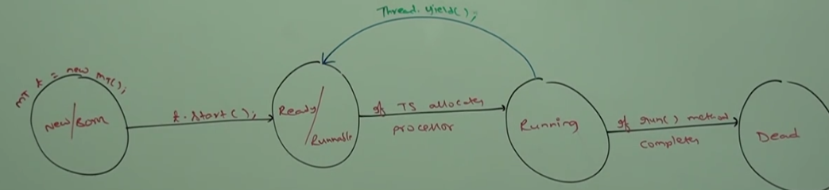

Thread.yield () 🡪Pause the current executing thread and give chance to the waiting thread of same priority.

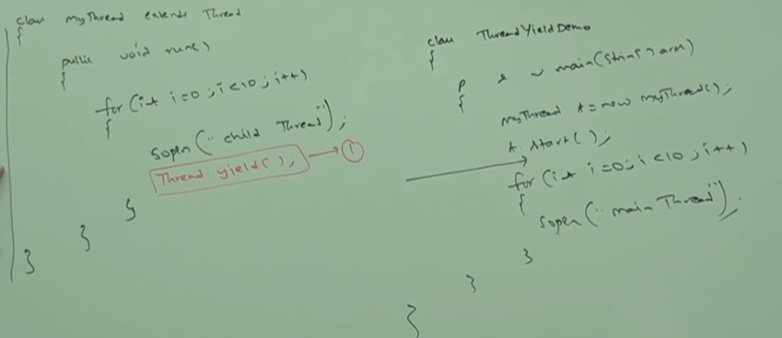

In the above program commenting the line “Thread.yield()”, then both thread will be executed simultaneously and we can’t expect which thread will complete first. If we are not commenting line 1 then child thread always calls yield method. Because of that main thread will get chance more number of times and the chance of completing main thread first is high.

**Some platforms won’t provide proper support for yield method.**

**Join method:**

If a thread wants to wait until completion of another thread then it will call the join method.

Ex1: If a thread t1 wants to wait until completion of t2 thread then t1 will have to call the join method on t2 thread i.e. t1 will call t2. Join (). If t1 executes “t2.join” then immediately t1 will be entered into waiting state until t2 completes.

Once t2 completes then t1 can continue its execution.

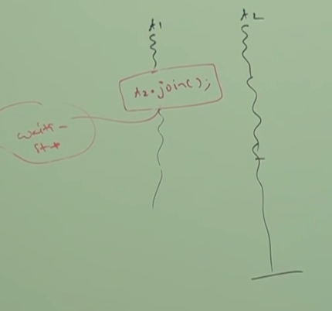

**Ex2:** 

In the above diagram t2 must wait until t1 completion. Hence t2 has to call t1.join.

t3 must wait until t2 completion. So, t3 has to call t2.join

public final void join () throws Interrupted Exception;

public final void join (long milliseconds) throws IE;

public final void join (long milliseconds, int nanoseconds) throws IE;

Every join method throws Interrupted exception which is checked exception. When a thread is waiting for another thread for completion then a third thread may interrupt the waiting thread.

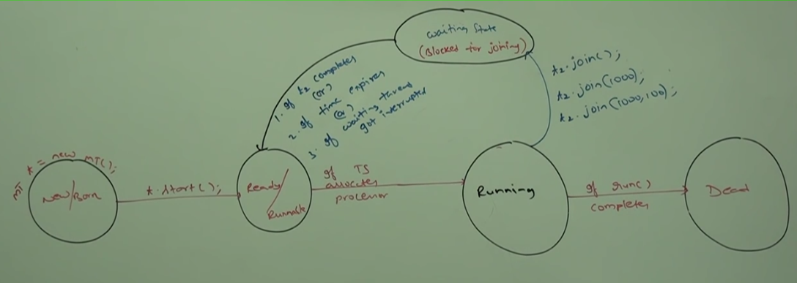

Impact of join methods in thread life cycle.

Waiting of main thread until completing child thread:

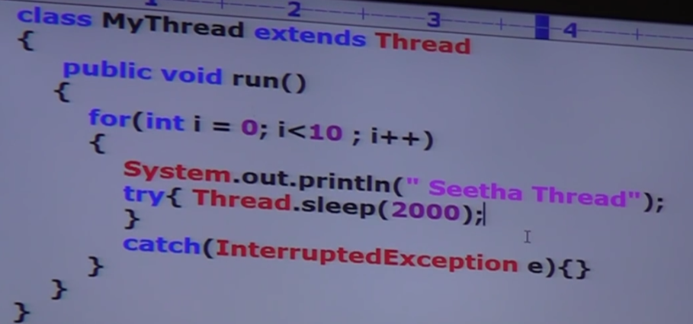

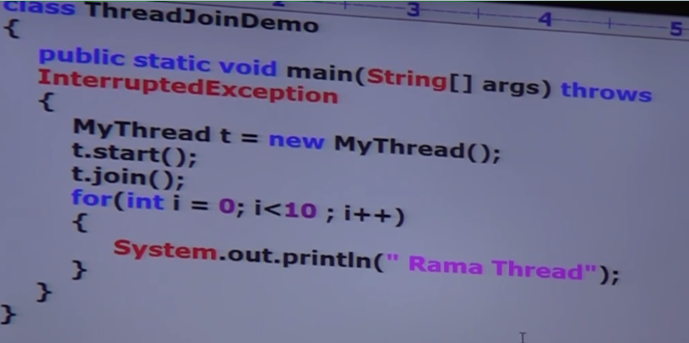

If we comment “t.join” then both main and child thread will be executed simultaneously and we can’t expect exact output.

If we are not commenting line 1 then main thread calls join method on child thread object. Hence, main thread will wait until completing the child thread. In this case

output: “Seetha Thread” 10 times followed by “Rama Thread”

**Waiting of child Thread until completing main thread:**

To access the main thread inside the child thread, create a static thread class inside child class and assign the main thread in main method.

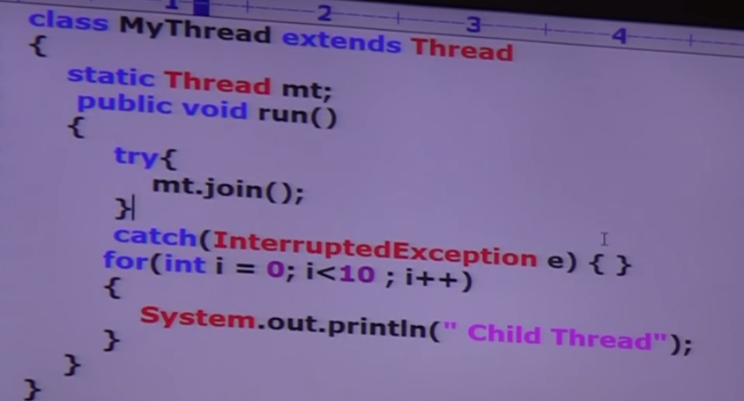

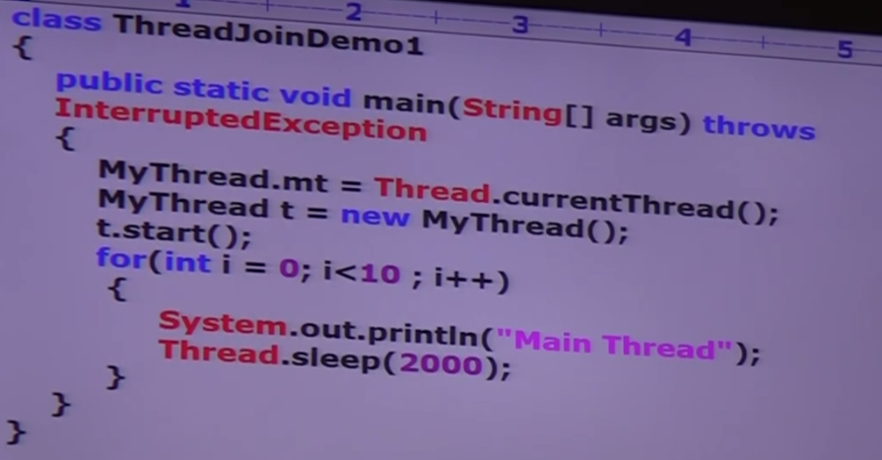

In the above example child thread calls join method on main thread object. Hence child thread must wait until completing main thread. In this case output is:

Main thread 10 times followed by child thread 10 times.

**Case3:**

If Main thread calls join method on child thread object and child thread calls join method on main thread object then both threads will wait forever. The program will be stocked. This is something like dead lock.

**Case4:**

If a thread calls join method on the same thread itself, then the program will be stuck (This is something like deadlock). In this case thread must wait infinite amount of time.

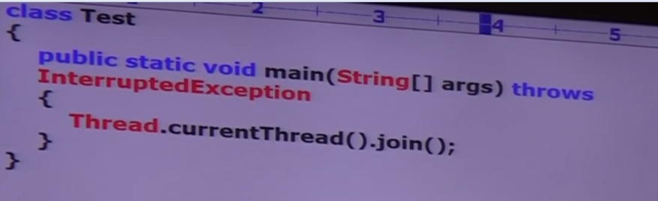

**Sleep Method:**

If a thread doesn’t want to perform any operation for a certain amount of time then we should go for **sleep** method.

Every sleep method throws IE, which is checked exception. Hence, whenever we are using sleep method

We should handle Interrupted exception either with try close or throws.

Public static native void sleep (long ms) throws Interrupted Exception;

Public static void sleep (long ms, int ns) throws IE;

Impact of Thread Sleep on thread life cycle.

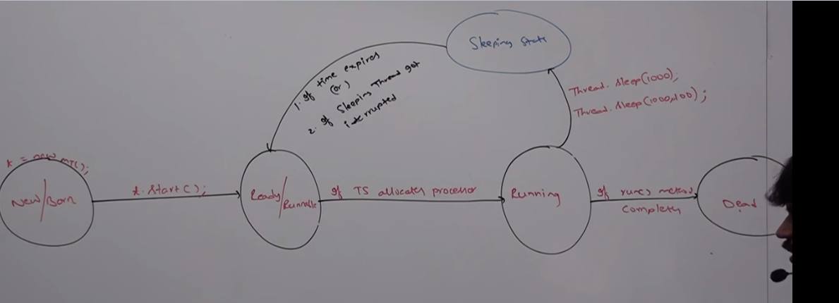

**How a thread can interrupt another thread**

Public void interrupt ()

A thread can interrupt a sleeping thread or waiting thread by using interrupt method of thread class.

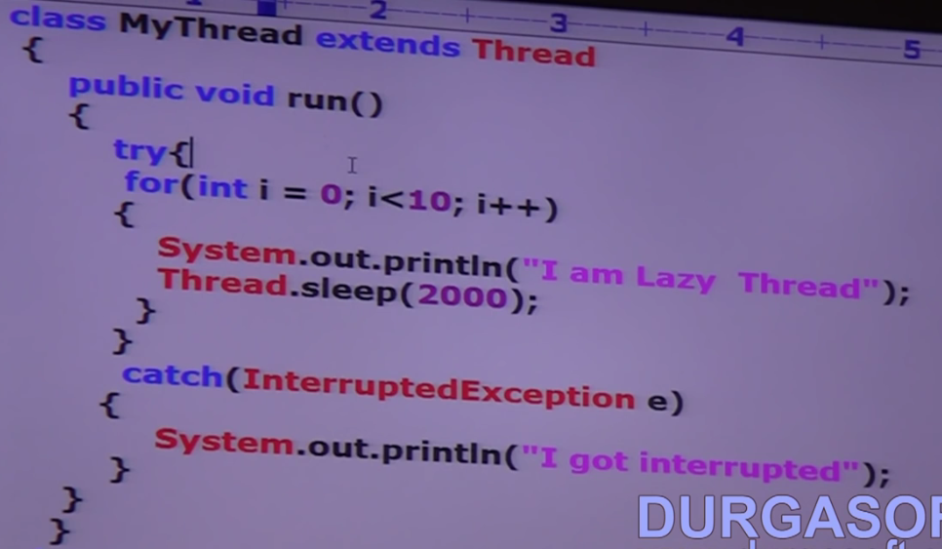

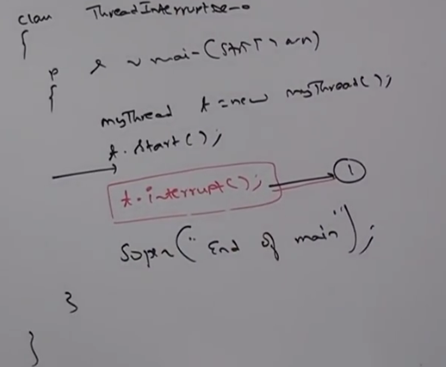

If we comment line 1 then main thread won’t interrupt child thread. In this case child thread will execute for loop 10 times.

If we are not commenting line 1, then main thread interrupts child thread. In this case output is:

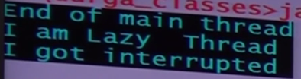

Whenever interrupt method is called if the target thread is not in sleeping/waiting state then there is no impact of interrupt call immediately.

Interrupt call will be waited until target thread enters sleeping or waiting state.

If the target thread enters sleeping/waiting state then immediately interrupt call will interrupt the target thread.

If the target thread never enters to sleeping/waiting state in its life time then there is no impact of interrupt call. This is the only case where interrupt call will be wasted.

**Comparison table of yield, join and sleep:**

**Yield:** If a thread wants to pause its execution to give the chance for remaining threads of same priority, then we should go for yield method.

**Join:** If a thread wants to wait until completing some other thread, then we should go for join method.

**Sleep**: a thread doesn’t want to perform any operation for certain amount of time, then we should go for thread method.

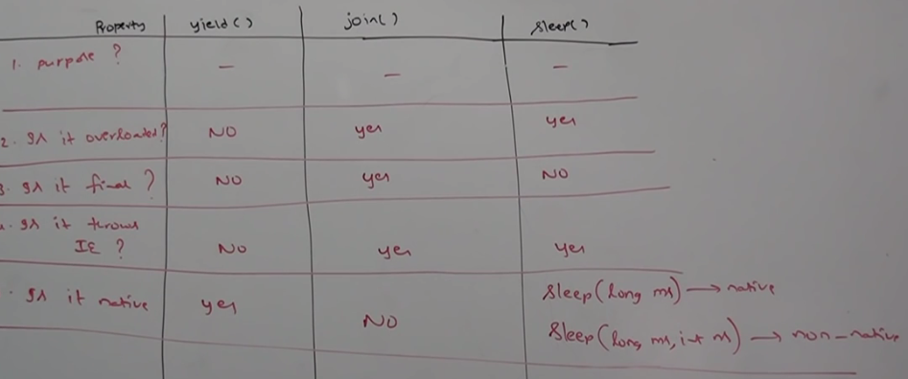

**Static**: Yield ->Yes, Join->No, Sleep-> Yes

**Synchronization:**

* + - 1. Synchronized modifier is applicable to **method and block but not for classes and variables**.
      2. If multiple threads are trying to operate simultaneously on the same java object, then there may be a chance of data inconsistency problem. To overcome this problem, we should go for synchronized keyword.
      3. If a method or block declared as synchronized then at a time only one thread is allowed to execute that method or block on the given object. So that data inconsistency problem will be resolved.
      4. The main **advantage** of synchronized keyword: we can **resolve data inconsistency** problems.
      5. The main **disadvantage** of synchronized keyword: It **increases waiting time of threads and creates performance problems**. Hence, if there is no specific requirement then it’s not recommended to use synchronized keyword.
      6. Internally synchronization concept is implemented by using lock.
      7. Every object in java has a unique lock.
      8. Whenever we are using synchronized keyword then only lock concept will come into the picture.
      9. If a thread wants to execute synchronized method on the given object first **it must get lock of that object**. Once thread got the lock then it can execute any synchronized method on that object. Once method execution completes automatically thread releases the lock.
      10. Acquiring and releasing lock is internally taken care by JVM and programmer is not responsible for this activity.
      11. **While a thread executing synchronized method on the given object, the remaining threads are not allowed to execute any synchronized method simultaneously on the same object.**

**But remaining threads are allowed to execute non-synchronized methods simultaneously**.

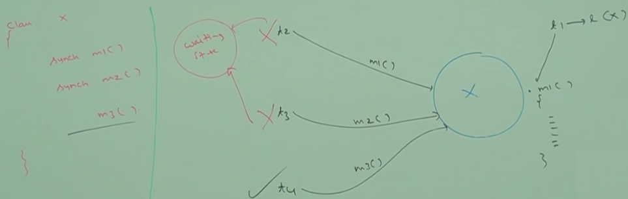

* + - 1. **Lock concept is implemented based on the object but not based on method**. So even if thread t2 calls m2 method it will go to waiting state. Because the X object is locked by the t1 thread.
      2. **Each object in java has 2 areas**:
         1. **Synchronized area**: This area can be accessed by only one thread at a time.

Where ever we are performing insert/update/delete. Here state of object changes.

* + - * 1. **Non-synchronized area**: This area can be accessed by any number of thread simultaneously. Wherever object state won’t be changed.

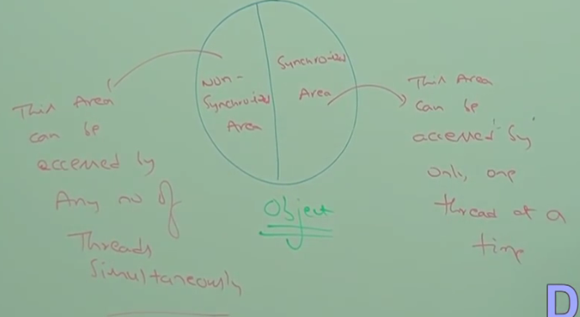

Example:

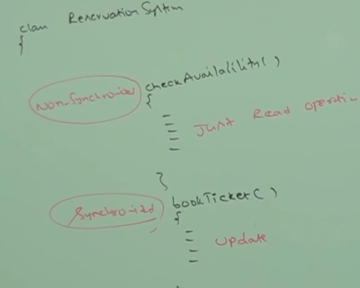

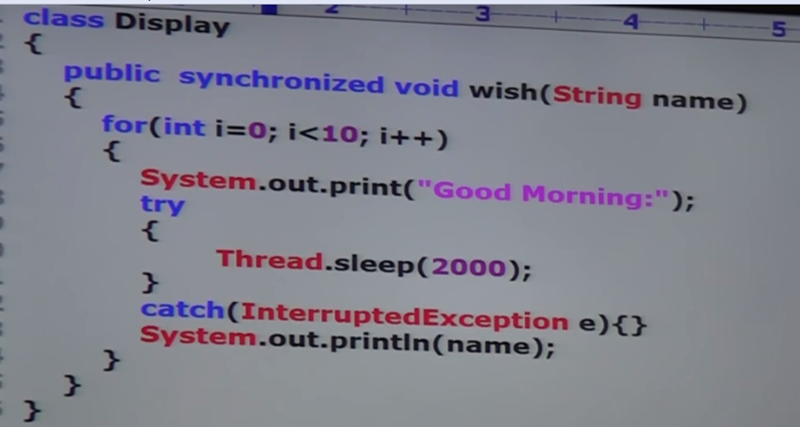

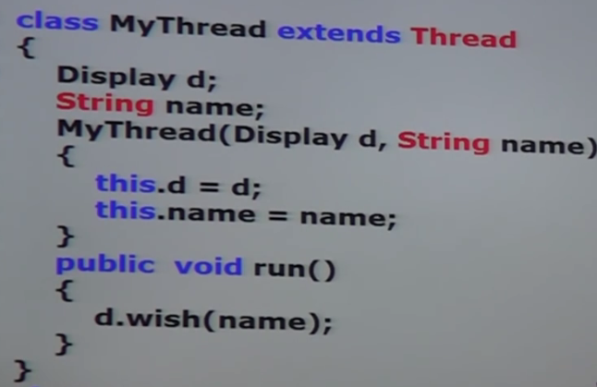

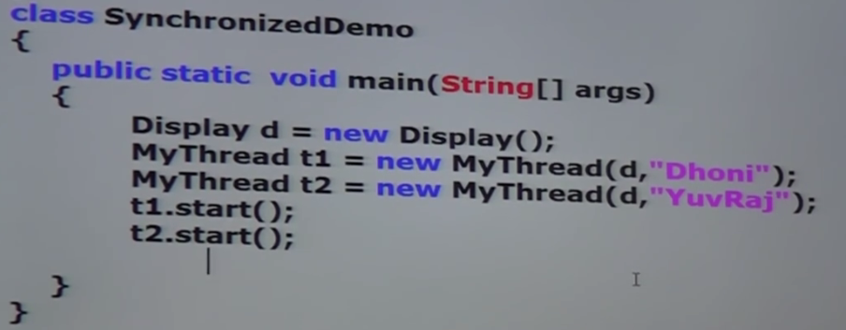

If we are not declaring wish method as synchronized, then both thread will be executed simultaneously. Hence, we will get irregular output.

If we declare wish method as synchronized then at a time only one thread can execute wish method on the given display object. Hence, we will get regular output.

**Case Study:**

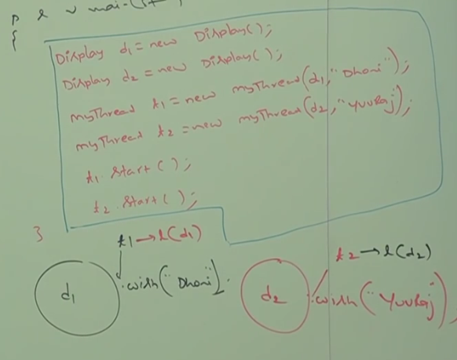

Even though wish method is synchronized, we will get irregular output. Because threads are operating on different java objects.

**Reason:**

**If multiple threads are executing on same java object then synchronization is required.**

**If multiple threads are operating on multiple java objects then synchronization is not required.**

**In Java 2 types of lock:**

* + - 1. **Object level lock**
      2. **Class level lock:** Every class in java has a unique lock which is nothing but class level lock. If a thread wants to execute static synchronized method then, thread requires class level lock.

Once thread got class level lock then, it can execute **any static synchronized method** of that class. Once method execution completes automatically thread releases the lock.

While a thread is executing **static synchronized method, the remaining threads are not allowed to execute any static synchronized method of that class simultaneously**. But remaining threads can execute the following methods simultaneously:

* + - 1. **Normal static methods**
      2. **Synchronized instance methods**
      3. **Normal instance methods.**

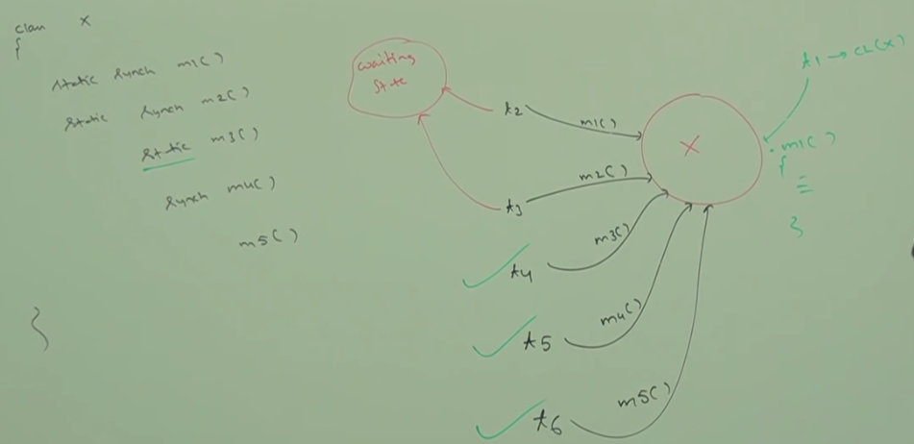

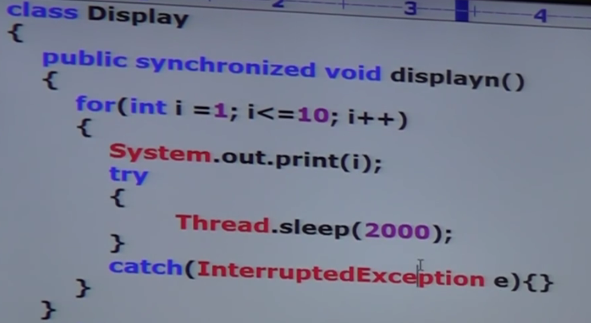

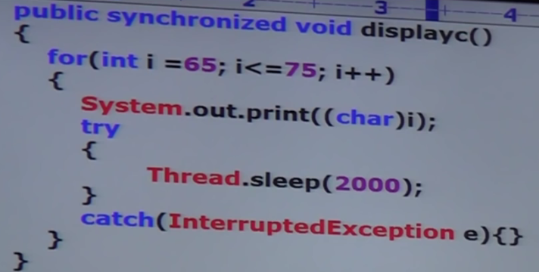

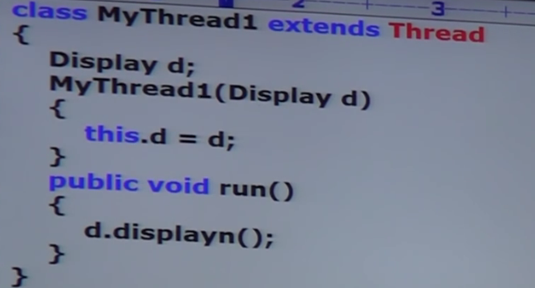

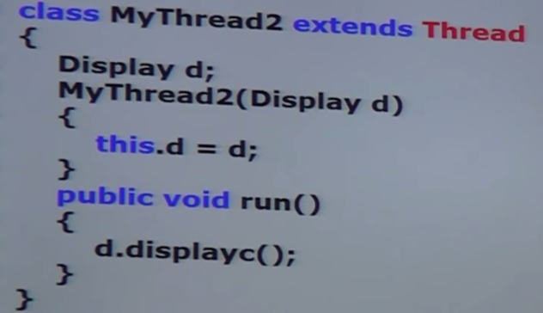

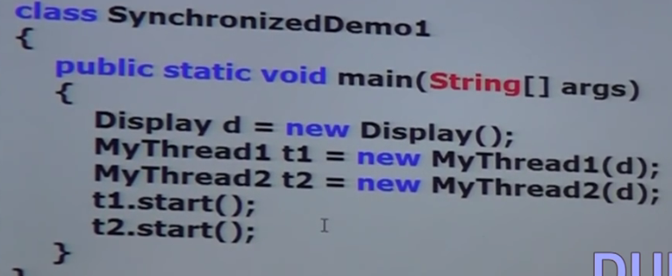

If a method is synchronized then no other synchronized method can execute simultaneously.

**Synchronized Block**

If very few line of the code requires synchronization then, it is not recommended to declare entire method as synchronized. We must enclose those few lines of the code by using synchronized block.

The main advantage of **synchronized block** over synchronized method is it reduces waiting time of thread and improves performance of the system.

We can declare synchronized block as follows:

1. **To get lock of current object:**

Synchronized (this) {

------

}

If a thread got lock of current object then only it can execute this area.

1. **To get lock of particular object “b”:**

Synchronized(b) {

----

}

If a thread got lock of particular object “b” then only it is allowed to execute this area.

1. **To get class level lock:**

Synchronized (Display.class) {

----

}

If a thread got class level lock of “Display” class then only it can execute this area.

**How to write synchronized block:**

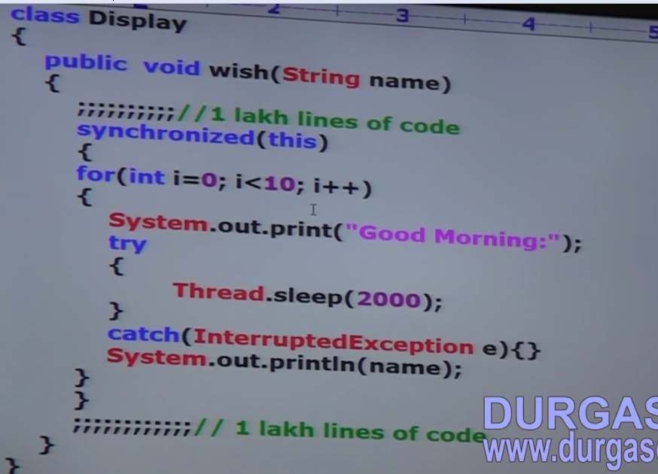

Complete program:

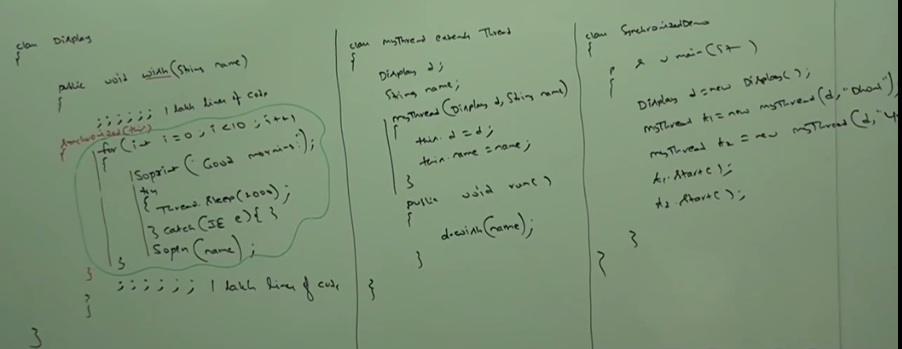

Lock concept applicable for object types and class types. But not for primitives. Hence, we can’t pass primitive type as argument to synchronized block.

Otherwise we will get compile time error saying “Unexpected type found: int

**Q1. What is synchronized keyword and where we can apply?**

Ans: Synchronized is a modifier applicable for methods, blocks but not for variables.

**Q2. Advantages of synchronized keyword?**

We can resolve data inconsistency problem.

**Q3. Disadvantage of synchronized keyword?**

It increases waiting time of thread and performance will be impacted.

**Q4: What is Race Condition?**

If multiple threads are operating on the same java object simultaneously and causing data inconsistency problem. To avoid Race condition synchronized method/block is used.

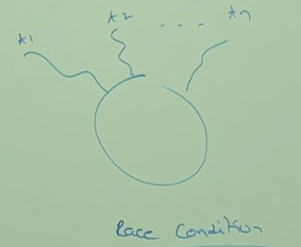

**Q5. What is object lock? When it is required.**

Every object in java has a unique lock which is nothing but the object lock.

Whenever a thread wants to execute synchronized method.

**Q6. What is class level lock and when it is required?**

Every class in java has a unique lock called class level lock. If a thread wants to execute static synchronized method class level lock is required.

Object level: instance synchronized method

Class Level: static synchronized method

Q7: What is synchronized block?

Q8: How to declare synchronized block to get lock of current object?

Ans: current object🡪synchronized(this)

Class level -> synchronized (ClassName.class)

**A thread can acquire multiple lock simultaneously from different objects.**

**Ex:**

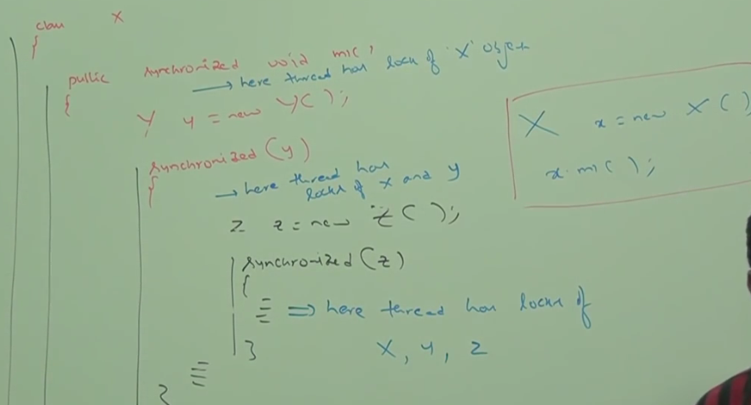

**Inter Thread Communication:**

Two threads can communicate with each other by using wait, notify and notify all methods.

The thread which is expecting updation is responsible to call wait method. Then immediately the thread will enter waiting state.

1. The thread which is responsible to perform updation, after performing updation it is responsible to call notify method. Then waiting thread will get that notification and continue its execution with those updated items.

Wait, Notify and Notify All methods present in **Object** class but not in thread class. Because:

1. Thread can call these methods on any java object.
2. To call the above 3 methods on any object, thread should be owner of that object i.e. the thread should have lock of that object i.e. the thread should be inside synchronized area. Hence, we can call wait, notify and notify all methods only from **synchronized** area. Otherwise we will get runtime exception saying “IllegalMonitorStateException”.
3. If a thread calls wait method on any object it immediately releases the **lock of that object** and enter waiting state.
4. If a thread calls notify method on any object, it releases the lock of that object but may not immediately.
5. Except wait, notify and notify all there is no other method where thread releases the lock.

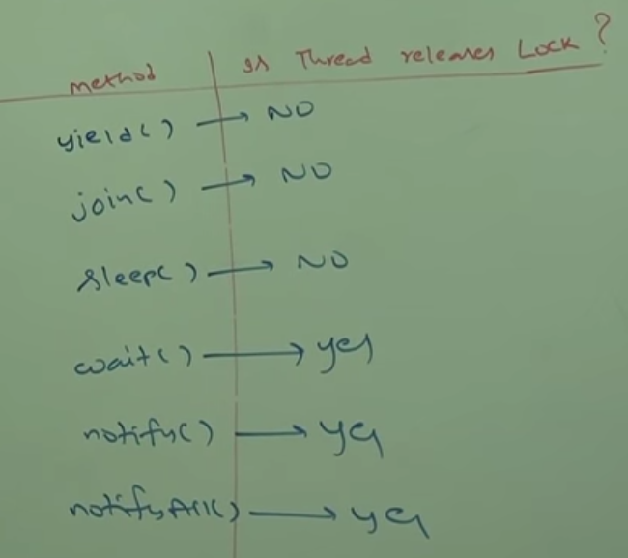

Exception in wait and notify methods.

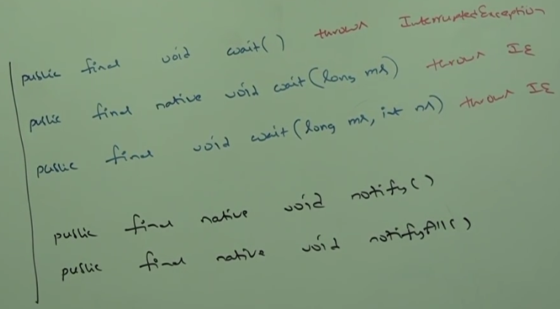

Every wait method throws interrupted exception which is checked exception. Hence, whenever we are using wait method we must handle “Interrupted Exception” either by try catch block or throws keyword. Otherwise compiler error will be there.

Thread Life Cycle in case of wait method

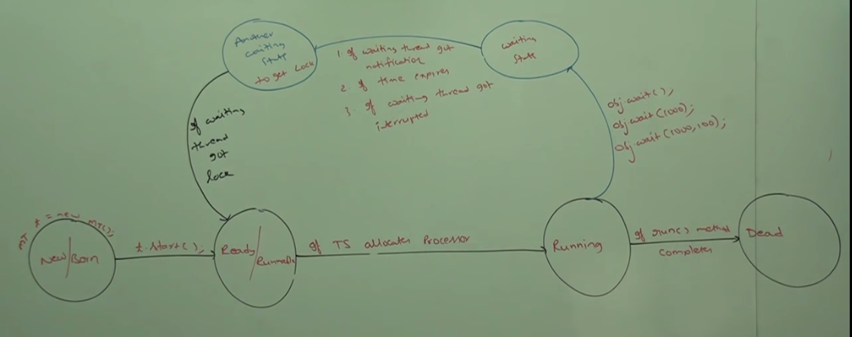

If a thread got notification it will go to another waiting state to get the lock. Because notify method releases the lock but not immediately.

Example:

If we are expecting updation go for wait, notify and notify all

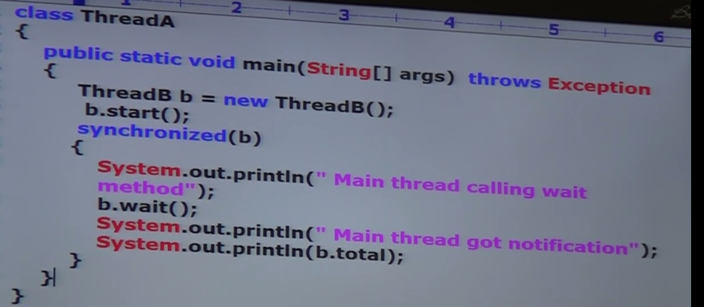

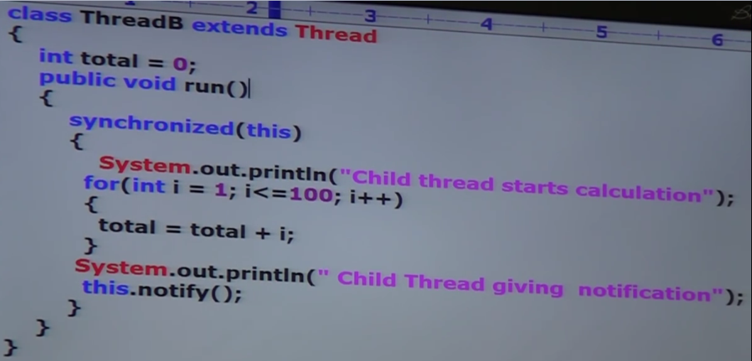

Output:

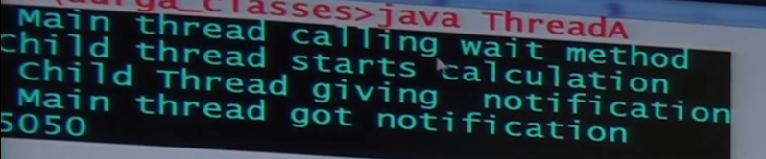

**Sequence of execution:**

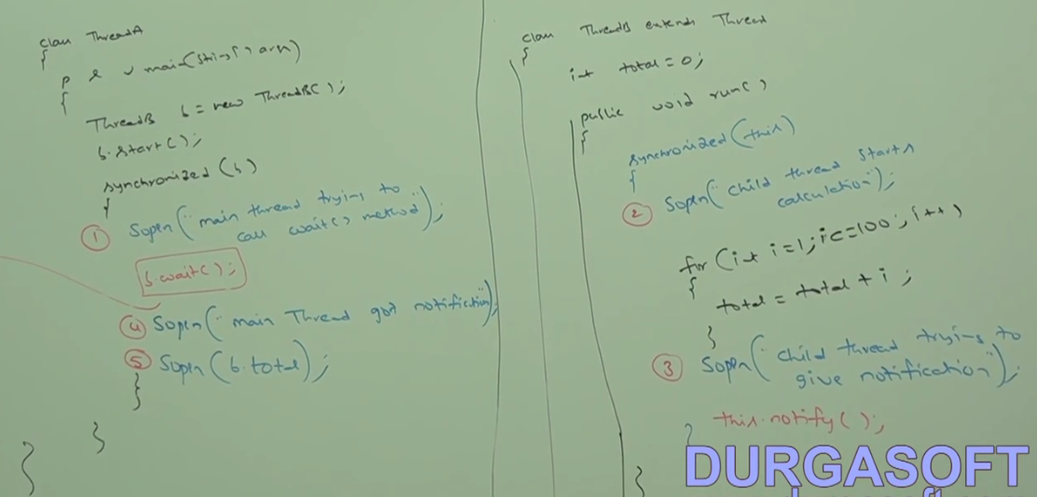

**Producer Consumer Problem:**

Producer thread is responsible to produce items to the queue and consumer thread is responsible to consume items from the queue.

If queue is empty then consumer thread will call wait method and enter waiting state.

After producing items to the queue, producer thread is responsible to call notify method. Then waiting consumer will get that notification and continue its execution with updated items.

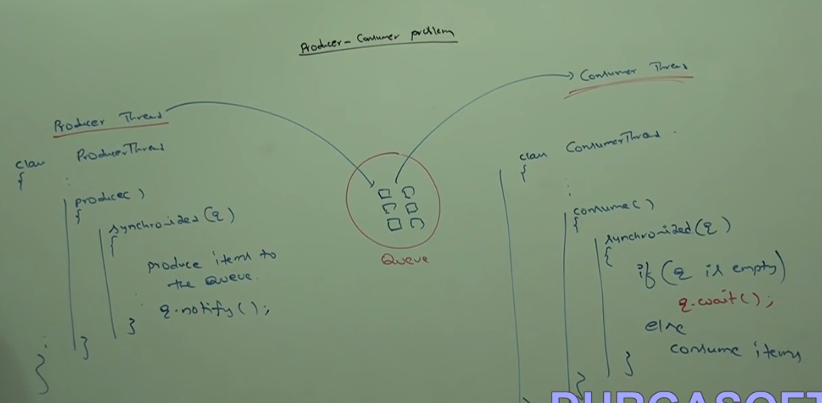

**Difference between notify and notify all**

We can use notify method to give the notification for only one waiting thread. If multiple threads are waiting then only one thread will be notified and the remaining threads have to wait for further notification.

Which thread will be notified we can’t expect. It depends on JVM.

We can use notify all to give the notification for all waiting threads of a specific object. Even though multiple threads notified but execution will be performed one by one. Because threads require lock and only one lock is available.

On the object, we are calling wait method. Thread require lock of that specific object.

If we are calling wait method on S1 then we must get lock of S1 object. But not S2 object.

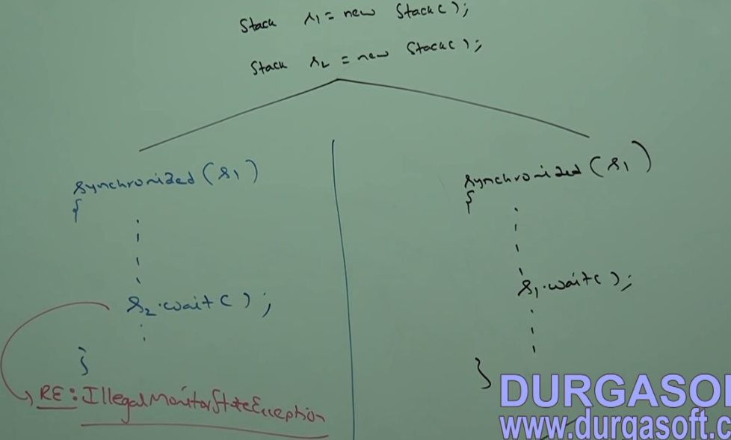

**Deadlock**

If 2 threads are waiting for each other forever. Such type of infinite waiting is called deadlock.

Synchronized keyword is the only reason for deadlock situation. Hence, while using synchronized keyword we should take special care.

There is no resolution technique for deadlock. But several prevention techniques are available.

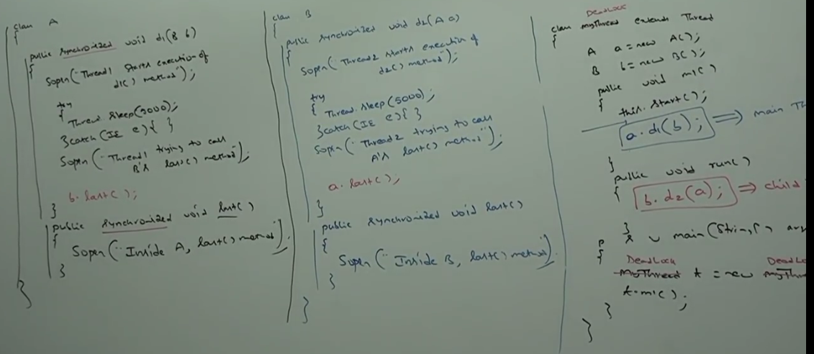

In the above program if we remove at least one synchronized keyword. Then, the program won’t enter deadlock state. Synchronized keyword is the only reason for deadlock situation.

While using synchronized keyword we must take extra precaution.

**Deadlock vs Starvation:**

Long waiting of a thread where the waiting of thread never ends- **Deadlock**

Long waiting of a thread where the waiting of thread ends after certain period- **Starvation**

Ex: Low priority thread should wait until completing all high priority threads. It may be long waiting. But ends at certain point, which is nothing but starvation.

**Daemon Threads:**

The threads which executes in the background.

Ex: Garbage Collector, Signal Dispatcher, Attach Listener.

The main objective of daemon thread is to provide support for non-daemon threads (Main thread).

Ex: If main thread runs with low memory then JVM runs garbage collector to destroy useless objects. So that number of bytes of free memory will be improved. With this free memory main thread can continue its execution.

Usually daemon threads have low priority. But based on our requirement daemon threads can run with high priority also.

We can check daemon nature of a thread by using isDaemon () method of thread class.

1. public boolean isDaemon ();

We can change daemon nature of a thread by using setDaemon method:

* + - 1. public void setDaemon(boolean b);

Changing daemon nature is possible before starting of a thread only. After start of a thread if we change daemon nature of thread we will get runtime exception: “IllegalThreadStateException”.

By default, main thread is non-daemon. For all remaining threads daemon nature will be inherited from parent to child i.e. if the parent thread is daemon then, automatically child thread is also daemon.

**Note**\*: It is impossible to change the daemon nature of main thread. Because it is already started by JVM at beginning.

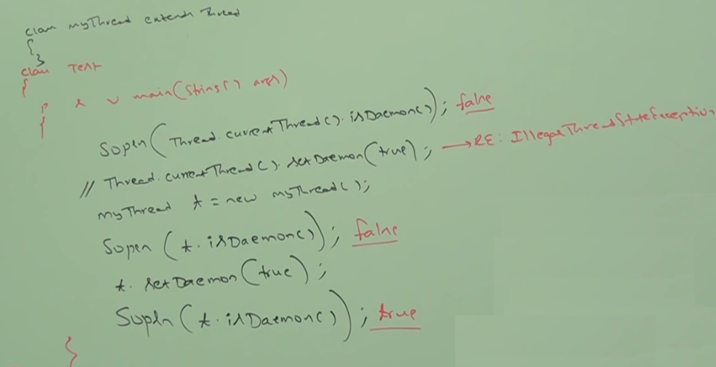

Whenever last non-daemon thread terminates automatically all daemon threads will be terminated irrespective of their position.

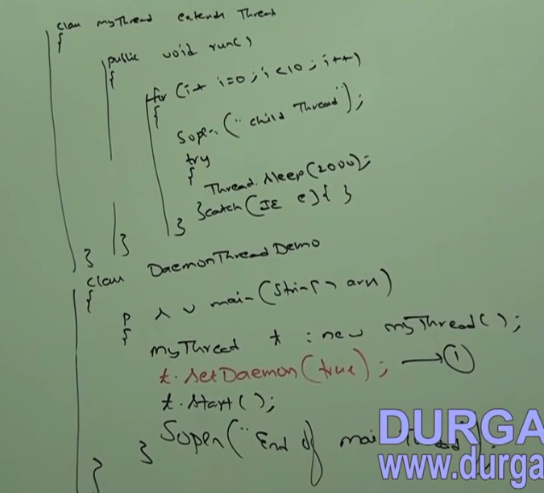

If we are commenting line 1, both main and child threads are non-daemon. Hence, both threads will be executed until there completion.

If we are not commenting line 1 then, main thread is non-daemon and child thread is daemon. Hence, whenever main threads terminate automatically child thread will be terminated. In this case output is:

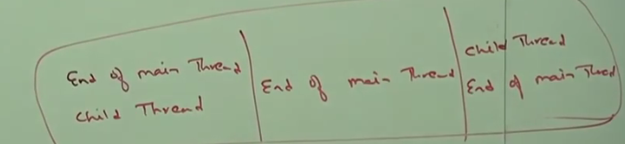

Java Multithreading concept is implemented by using following 2 models:

1. **Green Thread Model**: The thread which is managed completely by JVM without taking underlying OS support is called green thread. Very few OS like Sun Solaris provide support for green thread model. This model is deprecated and not recommended to use.
2. **Native OS Model**: The thread which is managed by JVM with the help of underlying OS is called native OS Model. All Windows based OS provide support for native OS Model.

We can stop a thread execution by using stop method of thread class.

public void stop ();

After calling stop method the thread will immediately enter to dead state. Stop method is deprecated and not recommended to use.

**How to suspend and resume a thread:**

We can suspend a thread by using suspend method of thread class. Immediately the thread will be entered suspended state.

We can resume a suspended thread by using resume method of thread class. Then suspended thread can continue its execution.

public void suspend ();

public void resume ();

These methods are deprecated and not recommended to use.

